At the time of Jesus there was a synagogue in every town and village in Palestine. The synagogue was a meeting place for the Jewish community. Jews attended a weekly service on the synagogue on the Sabbath. The synagogue was a plain, two –storey building. It was small, holding between fifty and a hundred people at a time. It had a porch in front with two doors. Women entered through one door and went upstairs to the gallery. Men and older boys went in another door and remained downstairs in the main part of the building. At the Sabbath service a rabbi read from a scroll or sacred scripture and gave a talk about the readings. Scrolls were treated with great respect because this was the Word of God for Jewish people. The scrolls were kept in a special part of a synagogue called the Ark. A curtain was drawn in front of the Ark, and a light burned beside it. The light was never allowed to burn out. It reminded Jewish people that God was always with them. In front of the Ark, a special candle holder called a menorah held seven candles. The weekly Sabbath service usually lasted an hour and ended with a blessing.
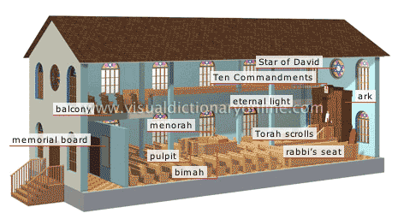
Questions
- How often did Jewish people attend a synagogue service?
- What did a synagogue look like at the time of Jesus?
- Where did people sit in the synagogue in Nazareth?
- What was the purpose of the Ark in the synagogue?
- Describe what took place during a synagogue service at the time of Jesus.

The Synagogue

