The Roman Empire
Mark in Ireland and Jerusalem on the Map.
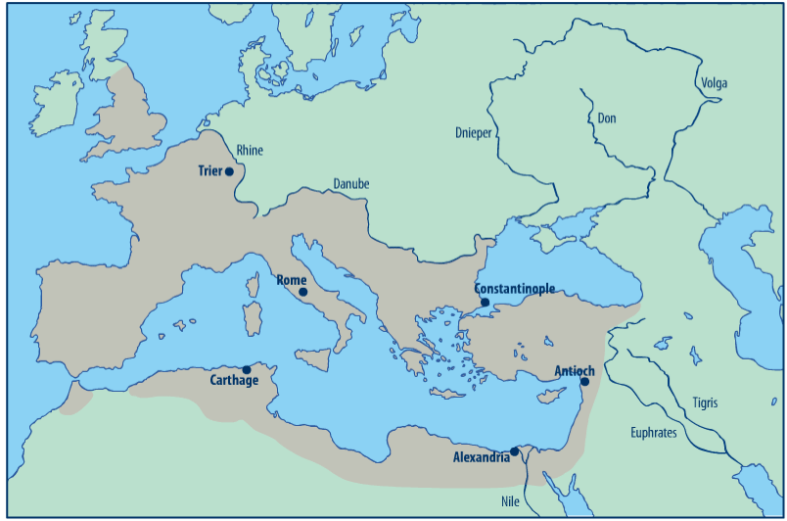

TRUE OR FALSE

Write 'True' or 'False' after each of the following statements.

- In 63 BCE, Palestine was conquered by the Roman Empire. ____________________
- The heart of the Roman Empire was Rome in Italy ____________
- The Roman Empire lasted for less than 100 years ____________
- The Romans imposed heavy taxes on the people of Palestine to pay for their armies and the Roman Empire. ____________________
- There was a political unrest under Roman Rule. ____________________
- Everyone in Palestine owned a horse. ____________________
- The Jews believed in multiple Gods while the Romans worshipped one God ________________
- Pontius Pilate ruled over Judea and Samaria ____________________________

