**Signs or Symbols?**

**Identify whether each of the following pictures is a sign or symbol.**

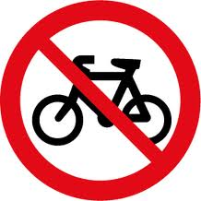 ________________ 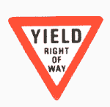 _________________

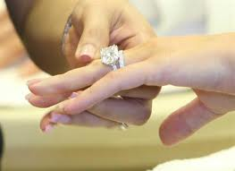 **____________ 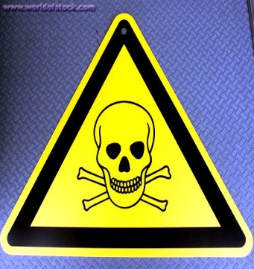 _____________**

**MCj03906320000[1]**

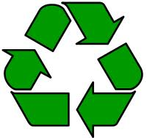 **_____________ _____________**

**C:\Users\Mum\Pictures\Microsoft Clip Organizer\j0335494.wmf  