Worksheet – Location and Culture
Locate where Judaism began on map. Circle the name of the country where Judaism began.
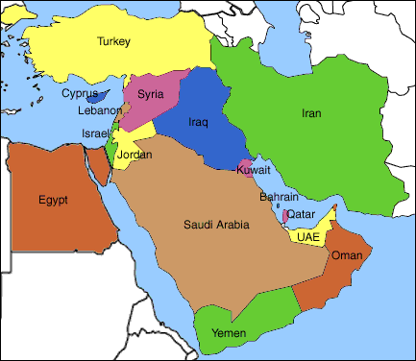
Match the terms with their descriptions.
The belief in many gods.
Cuneiform
Sheik
Polytheism
The leader of the clan. He was usually the oldest man.
Nomads
An early form of writing on clay tablets invented in Mesopotamia.

Large family groups who migrated from place to place in search of pasture for their animals.

At the time of Abraham, people worshipped many different gods. What type of Gods did they worship? ___________________________________
Draw one of these Gods.

